

*March 2017*

Blott Matthews Competition:

Airport to Airport

Jordan Taylor

**Report Authors:** Jordan Taylor, Thea Bautista, Amna Khan.

**Law section and guidance:**  Victoria White

**Supplementary Work:** William Shore

***Portsmouth College***

**London Airport Rapid Transit Solution**

Contents – Part 1:

**Overview**

Aim and Considerations 2

The Solution Map 3

**Planning and Environment**

Solution Overview 4

Future-proofing 5

Compulsory Purchase 6

Conservation Areas and Noise Pollution 7

Environmental Pollution and Heathrow 9

Hubs and Stations 10

**Civil Engineering**

Planning 11

Length of Construction and External Issues 12

Construction 13

Management and Reliability 14

Maglev Rail Traffic Management System 15

**Mechanical and Electrical Engineering**

Skytran Technology 16

Maglev Technology – EMS 17

Maglev Technology – EDS 18

Advantages & Disadvantages of EMS & EDS Systems 21

Maglev Vehicle Design 22

Skytran Vehicle Design 24

**Costs and Timing**

Considerations 25

Capital Costs of the Maglev Rail 27

Capital Costs of the Skytran System 28

Procurement of Hardware 29

Rail Construction Timetable 30

Appendices 31

References 45

Aim and Considerations:

Our Aim:

Our mission is connect the airports at Luton, Stansted, London City, Gatwick, and Heathrow to create one mega airport – allowing for the diversion of air traffic from one airport to another. Also, travelling to and from your point of departure and arrival and flight transfers would be less difficult. To connect the airports we have developed a rapid transit system to allow passengers to arrive at their desired “hub” irrespective as to their starting “hub”.

Considerations

Clearly we need a system that is fast, but we also need a system that is safe, economically viable, environmentally friendly, and able to cope with the passenger numbers. The system should employ existing technology so the implementation of the solution can be completed within the coming years.

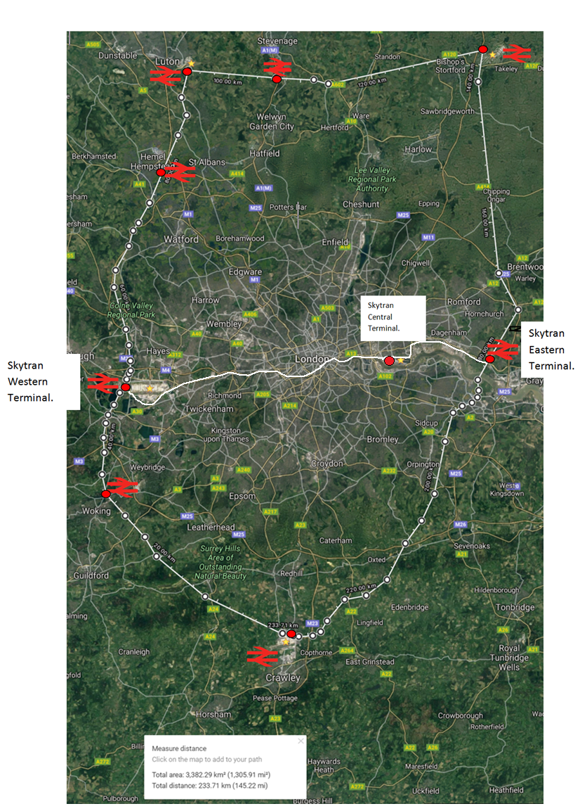The Solution Map:

*Figure 1: The rapid transit solution map. An outer maglev ring rail is combined with a high speed monorail.*

**Planning & Environment:**

Solution Overview

Our solution is comprised of:

* An EMS maglev train ‘ring-rail’ surrounding London and connecting its major airports
* An elevated PRT (personal rapid transit system) stretching across the ring’s diameter to connect London City airport.

Currently, Maglev trains are the fastest ground-based mode of transport in commercial operation which have been in commercial operation since 1979 although prototypes and models have existed since 1913.

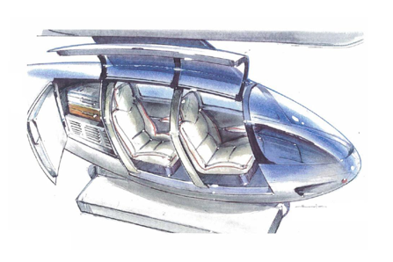The technology of the high-speed elevated PRT has been researched by NASA and the is patented by SkyTran. A prototype is planned in Tel Aviv, Israel. SkyTran also uses magnetic levitation.

The benefits of our solution are that both systems are faster than conventional means of transport. EDS and EMS maglev can reach top speeds in the region of 430km/hour and the SkyTran travels at a maximum 240km/hour.

Secondly, both systems have a low maintenance cost as both are levitating over guideways, resulting in less wear and tear (due to friction) than conventional transport. Also, the systems are environmentally friendly as there are no carbon emissions. Finally, the systems can operate in all weather conditions without delays.

*Figure 2: A concept illustration for a Skytran carriage.*

Multiple express transport systems were considered including Space X’s recent venture; The Hyperloop (see appendix **A**).

Future-proofing:

The proposed maglev rail is able to function as an airport-airport rapid transit system, surpassing the given passenger numbers by utilising 13 trains (7 clockwise, 6 anti-clockwise -see appendix **E**).

Despite the calculations of appendix e, the rail will be operating even further under maximum capacity at most times utilising 16 trains (two per station) therefore not only allowing for the future increase in passenger numbers, but allowing for the possibility of the ring’s commercialisation. Using all 16 trains means that, at any one time, the maximum number of passengers in transit is 9,600. Thousands of unbooked seats could be bought by members of the public, aiding the concept’s economic viability. In addition to the maglev rail there is a proposed connection between Heathrow, City Airport, and Aveley using the pioneering new technology ‘Skytran’. Used exclusively for transport to City Airport, Skytran makes use of a minimum of 317 high speed ‘pods’ (see appendix **H**).

SkyTran is easy to expand because it can branch off without interrupting its destination time. Maglev trains are difficult to expand however, because unlike a normal rail, maglev cannot have a branch coming off the track. The diagram below shows this because, unlike conventional trains, maglev must have parts surrounding the track (for electromagnetic levitation), therefore preventing paths from expanding. A possible way to allow expansion may be by the construction of another station – this would be between hubs. This would be needed if the demand from the public for high speed, high capacity trains were to grow.

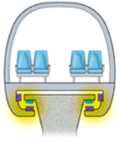  
Maglev’s guideways will last for around 50 years with very little maintenance, because the magnetic levitation means that there is no mechanical contact. In addition, the carriages are distributed uniformly rather than being focused on the wheels, and therefore, fewer parts are damaged in a given amount of time.

*Figure 3: A maglev carriage on its track.  
The lack of friction significantly reduces maintenance costs but causes difficulty for expansion prospects.*

Compulsory Purchase:

Land can be compulsory purchase if the purpose is in the public interest. For example, people who are seeking to build infrastructure such as rail ways, local authorities, and major utilities companies.

*‘Compulsory purchase powers are provided to enable acquiring authorities to compulsorily purchase land to carry out a function which Parliament has decided is in the public interest. Anyone who has land acquired is generally entitled to compensation.’*

Owners must be given at least 21 days’ notice, in which they can object to the compulsory purchase order [1].

**Greenfield sites:**

Green field land is typically known as sites that have not been previously built on, however this does include the greenbelt of land around the city. Greenfield land is typically cheaper however this also means countryside increasing traffic and congestion leaving the city centre. To buy this land, it can typically cost anywhere between £4,000 - £10,000 per acre and anything up to £200,000 an acre with planning permission. However, when building on Greenfield land 5 points must be followed in accordance of the NPPF:

* Check the unrestricted sprawl of large built-up areas.
* Prevent neighbouring towns from merging into one another.
* Assist in safeguarding the countryside from encroachment.
* Preserve the setting and special character of historic towns.
* Assist in urban regeneration, by encouraging the recycling of derelict and other urban land.

See appendix **B** for approximate calculations concerning the compulsory purchase of greenfield land. Best case scenario, the land area can be bought for £4.6 million.

[2] [3]

**Brownfield sites:**

Brownfield land is land which is currently occupied by a permanent structure or used for agricultural purposes as well and land which has been used for excavation or disposal of waste. This land is typically more expensive than Greenfield however it primarily depends on it location and how expensive the site would be to clear from its previous use so it may be reused. This land is typically feared to be contaminated or hazardous however with regulation of contaminated land the UK, the local authorities must have a ‘contaminated land register’ as part of the Environmental Protection act 1990. [4] [5]

Conservation Areas and Noise Pollution:

**Conservation Laws:**

Protected Areas (Conservation land) are locations which have received protection due to an endangered wildlife species or culturally recognized landmark. These pieces of land are not allowed to be built on if it would break any laws under the following legislation: [6].

* Ancient Monuments and Archaeological Areas Act 1979
* Badgers Act 1991
* Countryside and Rights of Way Act 2000
* Environment Act 1995
* Environmental Protection Act 1990
* National Parks and Access to the Countryside Act 1949, Planning (Listed Buildings and Conservation Areas)Act 1990
* Protection of Badgers Act 1992
* Weeds Act 1959
* Wildlife and Countryside Act 1981

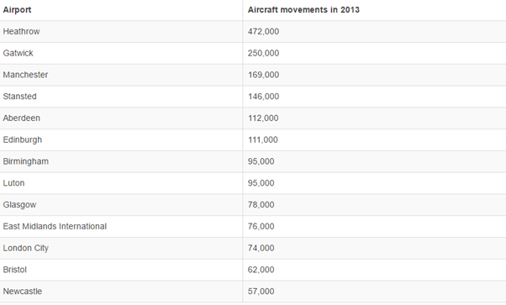**Noise Pollution:**

*Table 1: Number of aircraft movements in 2013:*

Leq (equivalent continuous sound level). An equivalent continuous sound level that is above 57dBA is considered large enough to irritate the local community.

**Lden** uses an annual average of the equivalent continuous sound level but also considers the disturbance of noise later in the day (evening and night).

*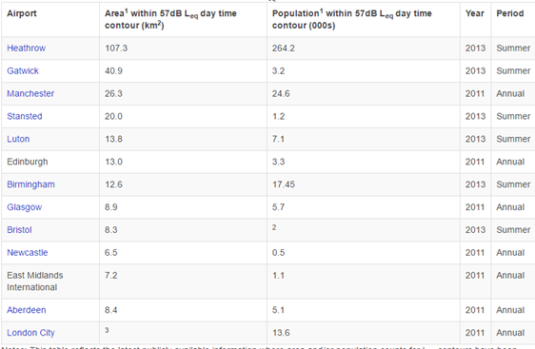Table 2: Communities affected by noise around different airports Leq:*

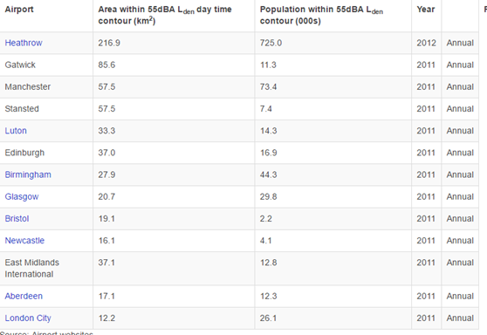

The transit system will mitigate the amount of planes flying over London, decreasing noise pollution.

*Table 3: Communities affected by noise around different airports Lden:*

Environmental Pollution and Heathrow Expansion

The Heathrow Expansion provides an estimated climate cost of £4.8 billion in its report but should instead be £14 billion largely due to underestimation. This value itself is enough to discredit their focal argument of a net economic benefit of £5 billion (see appendix **F**).

The air quality around Heathrow is consistently in breach of the standards required by the EU and the expansion would only worsen this. The increase in carbon emissions will not only affect us but more so those living in less developed countries that are unable to adapt to climate change. With the increased number of flights that the expansion insinuates, not only will air pollution increase but also noise pollution which will greatly affect surrounding population (cancellation of the expansion would not only prevent this, but ease the strain of meeting EU CO2 emission standards for other sectors).

Proceeding with the proposed maglev and Skytran transit system may mitigate the need for the controversial Heathrow expansion - instead opening up the opportunity to expand either Luton or Stansted airport into surrounding uninhabited land. Passenger numbers would also be more evenly distributed.

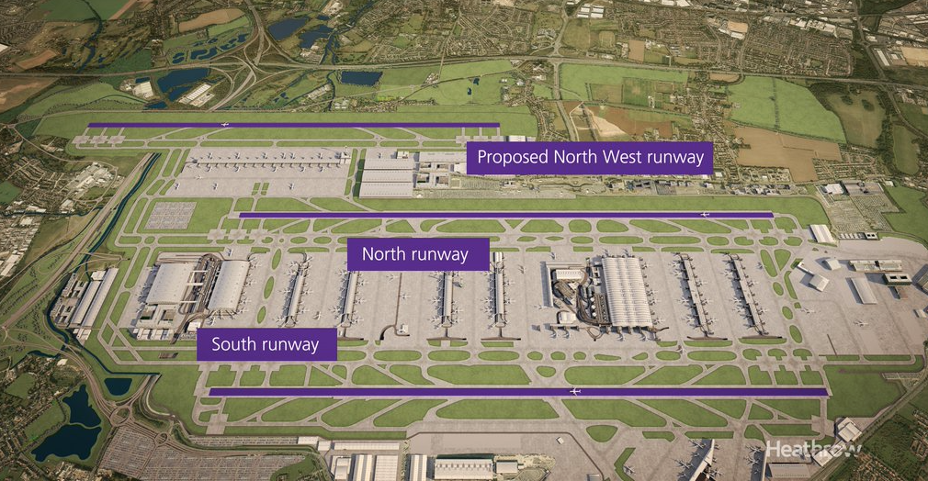

*Figure 4: A computer generated image of the Heathrow expansion, the close proximity to the London suburbs means that there would be a large amount of disruption for local residents during and after construction.*

Hubs and stations:

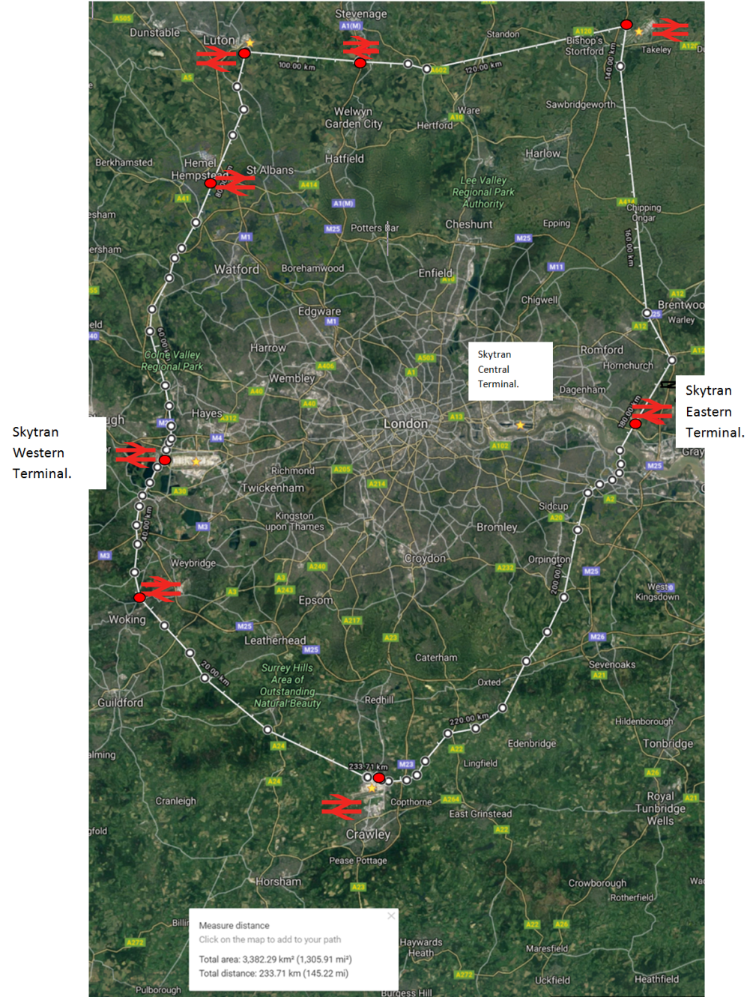

The diagram to the right depicts the proposed route with indicated stations. Alongside the stations at the airports, four additional stations have been planned for passenger convenience situated at Woking, Hemel Hempstead, Stevenage, and Aveley. Not only is each station in somewhat close proximity to Motorways and A-Roads, but each is located on the outskirts of one of London’s satellite towns. This aids the prospect of opening remaining seats for sale to the public, opening up employment opportunities in connected towns for workers due to the sub 20 minute commute time.

Each proposed additional stop will function very similarly to the airport hubs, enabling the pick-up and drop-off of passengers. However, unlike a conventional train, all seats must be booked in advance to avoid potentially hazardous overcrowding of the maglev rail. Air faring passengers will book their seat with their flight whereas non flyers will book theirs independently but will be prioritised second.

*Figure 5: The route map for the proposed Maglev Ring-rail.*

**Civil Engineering:**

Planning:

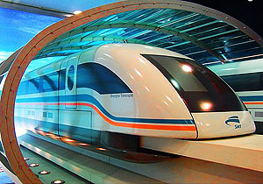One key fact that we must consider and understand is that a concept like Skytran will take a long time to realise, partially because the project itself was conceptualized in 1990 and was then later patented by the U.S. government in 1992 [8]. This information would then seem to tell us that although the project is still a concept, it is definitely possible using the maglev pods for transport. However, the building of the structure that holds the pod in the air is another story in terms of how and when to build it. The planning of the project is paramount to the success of the overall introduction to other consumer countries.

Maglev transportation has already been integrated into the transport system of different countries and because our maglev system utilises electromagnetic magnetic levitation, a system already developed and applied in several countries including the UK, planning on the technology aspect of the project won’t take too long. The development of the layout of the tracks as well as receiving permission for the construction of the tracks would likely be the longest within the planning process.

*Figure 6: The already existing Shanghai maglev train.*

Length of construction and External Issues:

Length of Construction:

An estimate as to how long the transit system will take to build is three years (as of this year), as the first SkyTran system will be opened in Lagos in the year 2020 [9]. Analyzing this information, we can see that if we start building in this year we will need to run a test length of 25 metres and after doing so we can build upon this test. The cost according to the article referenced was far less than building a new subway/railway system. Therefore, including a year for testing and then another consecutive 3-5 years on construction we could see a SKYTRAN system in the UK by 2021-2022.

The construction of the Shanghai Maglev line started on 1 March 2001 and became commercially available by 2004 [10]. If the line built was approximately 18.6 miles, then it would have taken them 2 months to one mile of track. Following this as a guide (as the track built was for an EMS maglev system), then it would take roughly 23.3 years to build our maglev track with an approximate length of 140 miles. However, the Shanghai Maglev faced many delays such as poor soil around the construction sites which led to a revision of their plans. Not to mention, this included the construction of large concrete supports and a concrete track as well as two stations. These would have added to the time considerably and thanks to better technology and the fact that our maglev train would be built on the ground (Track placed directly on the ground after foundations and levelling work) the construction time for our maglev system should be noticeably less than 23 years. Once the foundations have been placed for the track, a factory train can promptly place the rail (figure 7).

External Issues:

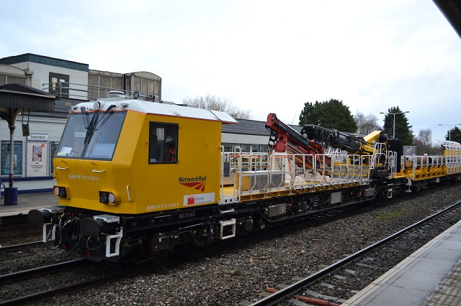  
The main issues with construction are the noise pollution and the disruptions caused to local small business and day to day traffic. According to the government website, the times in which construction teams can work is between 7 am to 7 pm on weekdays, and 8 pm to 1 pm on Saturdays. The roads on which public housing is nearby will be subject to noise pollution for a given period of time. Taking this into account, the team has to put in place health and safety measures to avoid any harm to the public and to the employees. This can easily be done through placement of signs, and barriers and following legal statutes on public and employee safety [11].

*Figure 7: The Brunel class factory train rapidly builds tracks after foundations have been placed. A Maglev variation would be deployed for track construction.*

Construction:

SkyTran is made of three simple units; plain steel poles, aluminium guideways, and inexpensive fibreglass pods. The elements are pre-manufactured. The steel poles will be erected like lamp posts. Basically, you place it in the ground and cover it with concrete. They will be placed in a linear fashion and will hold the guideways. The guideways snap together. The pods fit within the guideways and are held there through a magnetic field. The system can be built alongside the present infrastructure.

Maglev trains are not compatible with conventional rail tracks, an EMS maglev train cannot share an existing rail infrastructure with a regular train hence new ‘tracks’ must be built separately adding to the cost  of the system. The guideway (‘tracks’) of the train will not be elevated so supporting columns will not be needed, unlike the Shanghai Maglev which requires a concrete column every 50 metres for stability [10]. However, the ground on which the tracks will be built may require levelling to remove any sudden inclines. Another advantage to the EMS system is that it is able to operate at all speeds unlike maglev trains that employ electrodynamic suspension (EDS) which necessitates a minimum speed of at least 140km/h for levitation to occur. Because of this, EMS systems do not require a separate low-velocity suspension system and a simpler ‘track’ can be used cutting costs further.

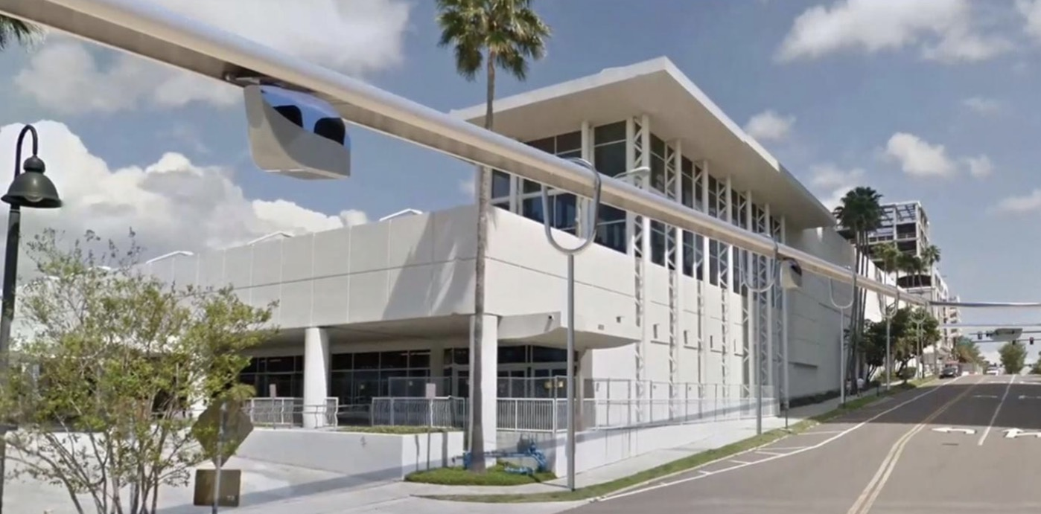

*Figure 8: SkyTran’s concept station. Its single rail is suspended alongside the road.*

Management and Reliability:

Skytran:

Skytran is constructed from lightweight aluminium – it doesn’t rust so it can therefore withstand the weather in London. The other major concern is the strong winds. To avoid future problems, the structure should be tested. The vehicle has enough onboard energy to reach nearest station to disembark in case of emergencies. If there is a fault in the lines, the vehicles will be redirected through a different route while the line is being fixed.

Maglev

Maglev trains, though they have not been tested against a cornucopia of weather conditions, are little affected by heavy rain, snow or cold weather so it would be able to endure the weather in London. Evident from present maglev, the system requires very little management as it avoids the considerable wear due to friction that regular commercial trains experience. Compared to conventional InterCity Express (ICE) trains, EDS systems allow for higher speeds and gradients with less maintenance needed as there is no contact between the train and the guideway. Furthermore, the tracks are more flexible and therefore are more easily adapted to specific geographical circumstances.

In case of emergencies, the maglev train is equipped with its own emergency power supply which it can rely on for approximately one hour which is more than enough time to lead it to the next station [12].

A central control and operations centre would be used which would have full control of the position of the train as well as other safety features. Each train will be fully monitored each time and their locations tracked to prevent crashes. However, in the unfortunate event of a mechanical failure, the maglev trains will need to be winched off the track using a mobile crane.

Maglev Rail Traffic Management System:

Most conventional rail networks utilise complex management systems to avoid collisions, ensure trains depart and arrive on time as well as increase overall efficiency. Such systems (notably the European Rail Traffic Management System (ERTMS)) [13] function by relaying the positions of each train to a central computer wherein the optimal speed is calculated and used as part of an informative display for the driver.

Although currently used for managing a large pan-European rail network, it is possible for a system very similar to ETMRS to be simplified for use on the linear proposed maglev rail loop. Fully functional and safe for speeds up to 500km/h (139 ms-1), therefore an adapted ETMRS is compatible with high speed maglev trains.

In our adaptation, each train will relay its position and current velocity via satellite to a central computer. The calculated velocity is then recommended to the driver while still allowing full control (allowing manual override in the event of a system glitch).

By utilising a high speed maglev ring-rail around London as well as the Skytran personal transit to access City Airport, passengers can board at any station and arrive at any airport in less than the 20 minutes excluding the five minutes allocated to boarding (see appendices **C, D, E**).

**Mechanical and Electrical Engineering:**

Magnets have at least two poles, North and South and everyone knows the saying that opposites attract and like poles repel. This forms the groundwork for magnetic levitation. We looked at two pieces of technology using magnetic principles for transportation, maglev trains and SkyTran. The benefit in using magnetic levitation is it virtually removes all friction, which allows the vehicles to reach high speeds

SkyTran

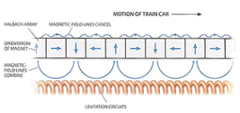  
SkyTran is a revolutionary method of a personal rapid transit system developed by NASA. You would be able to call a jet-like pod to your location, like a taxi service, and the driverless pod will take you to your destination. The pods ride on a cushion of air between elevated guideways and are controlled by a supercomputer to minimise traffic and collisions. The lightweight vehicles are fast (150 mph/240 kph), cheap, environmentally friendly and quiet as there are very few moving parts.  
Unlike conventional public transport, there are no schedules. This allows the users to go straight to their destination when they want. In addition, they don't have to waste time stopping at other stations. One pod can carry two adults and their luggage/wheelchair/bicycle. Pods can be connected to travel as a "caravan" for families to travel together.

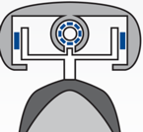Magnetic Levitation   
The secret is in using magnetic levitation to virtually remove all friction, which allows the vehicles to reach high speeds. When a permanent magnet goes over non-attracting aluminium it generates an eddy current. When a metal is moved at right angles ( or any angle except parallel to) in a magnetic field, a current is induced in the metal. These are eddy currents. Similarly, if a magnet is moved in a coil of wire or a tube then a current is induced in the tube or wire.   
  
These currents then go on to induce magnetic fields in the metal. The direction of the magnetic field induces will always oppose the motion producing them ( Lens's Law) otherwise you will break the laws of conservation of energy. These are often called back eddy's. This will cause the metal or magnet to slow down or stop due to repulsion unless a force is provided. The repulsion causes the vehicles to levitate and the force causes the propulsion.  
  
Coils of wire are put along the aluminium guideway and each pod contains linear motors wrapped in neodymium magnets in 4 "wings" up against the guideways. These linear motors fit within the guideway in a cylindrical opening called "reaction rails". As the vehicle zips pass the coils it induces its own magnetic field generating current, lifting the pod approximately 1 cm above the track due to the repulsion. The vehicle only requires an initial burst of energy for uplift. There is no contact between the vehicle and the rail.  
  
Due to the spiral array of magnets angled forward, the rotation of this neodymium magnet is what causes the forward propulsion.

*Figure 9: Diagram depicting SkyTran’s levitation technique.*

*Figure 10: Simplified diagram depicting the propulsion method of Skytran.*

Maglev Trains:

As the name suggests, maglev trains are a form of high-speed transportation which incorporates magnetic levitation to enable the train to essentially *float* on a guideway, reducing the impact of friction on the train and consequently increasing its maximum speed making maglev trains one of the fastest trains in the world.

There are two types of magnetic levitation we chose to focus on:

·         Electromagnetic Suspension (EMS)

·         Electrodynamic Suspension (EDS)

How it works: Electromagnetic Suspension (EMS):

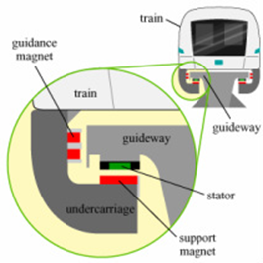EMS trains use the force created by the attraction between electronically controlled electromagnets in the train and a magnetically conductive track to levitate it [14]. This form of maglev train was first used in the German Transrapid System and was later implemented in 2004 to create the first (and currently the fastest) commercially available maglev train: the Shanghai Maglev Train which is capable of travelling 30km in 7 minutes and is able to achieve a top speed of 431 km/h [15]. One of the latest applications of electromagnetic suspension on trains also includes the Incheon Airport Maglev which became commercially operational on February 3, 2016.

EMS trains use individual electronically controlled electromagnets in the vehicle which are attracted to the ferromagnetic reaction rails found on the underside of the guideway [14]. Support magnets pull the carriage towards the guideway [16] which overcomes the gravitational force acting on the train whilst guidance magnets keep the vehicle on track from both sides preventing the guideway and the train from making contact and ensuring that it travels in the direction of the track.

*Figure 11*

A longstator linear motor (which is essentially a traditional rotating motor whose stator has been unrolled and stretched out along the underside of the guideway facing the support magnets) is installed along each side of the guideway to provide propulsion and braking [17]. The polarity of the stators (permanent magnets) on the track are able to quickly change their polarity continuously to move the train. A travelling magnetic field is induced by supplying a three-phase motor winding with an alternating current which pulls the carriage along the guideway [14]. The track is separated into sections which turns on and off automatically when the train moves from one section to the next and more power is provided to areas of higher gradients and acceleration to improve economic viability.

An electronic control system ensures that the train levitates at a constant height of 10mm from the guideway even at a lower velocity [17] creating enough space between the train and the guideway for frictionless transport. Furthermore, because it can work at low speeds, it eliminates the need for wheels or any other form of low-speed suspension system allowing for a simpler track design.

To prevent crashing into the guideway, the EMS train is also equipped with its own emergency battery power supply in the case of power failure and can rely on this power source for approximately one hour.

How it works: Electrodynamic Suspension (EDS):

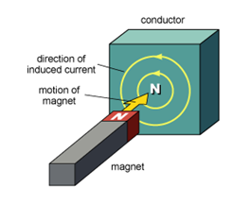This form of magnetic levitation was invented by Japanese engineers and is what enables the fastest train, JR Central's L0 superconducting Maglev from the Chūō Shinkansen line, to reach unprecedented speeds of over 600km/h [18]. It uses magnets that have the same polarity to create repulsive forces which would be greater than the weight of the train and so, will levitate it. It works on the principles of electromagnetic induction where a current will be induced by the change in magnetic field within the conductor which was caused by the movement of a magnet beside the same conductor as shown in figure 12. This induced current will in turn create a magnetic field which will resist the change that caused the induction in accordance to Lenz’ Law [19]:

*Figure 12*

“Induced electromotive force generates a current, which flows in such direction as to induce a counter magnetic field that opposes the magnetic field generating the current” [20]

*Figure 13*

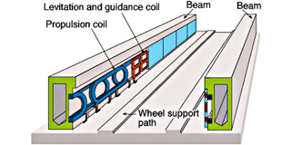Figure 13 on the right shows the components and layout of a maglev train that uses electrodynamic suspension. EDS systems can only levitate the train using magnets on board and cannot propel it therefore a separate piece of technology must be used to create acceleration hence why the track features both a levitation and propulsion coil.

Figure 3 also shows the components and layout of a maglev train that uses electrodynamic suspension. EDS systems can only levitate the train using magnets on board and cannot propel it therefore a separate piece of technology must be used to create acceleration hence why the track features both a levitation and propulsion coil.

Maglev Levitation (EDS):

There are a series of ‘8’-shaped coils lining each side of the guideway (shown in red, figure 13 – page 18) which allow for the train to levitate. These are made of metal and are not linked to a source of energy thus they are passive [21]. Superconducting magnets on the train pass by these coils at high speeds just below the centre of the levitation coils so that the magnets on the train induces a current within the coils which has a greater magnetic flux change in the lower half of the coils than the top half (as shown in figure 14 b). The current induced under these circumstances generates a magnetic force strong enough to allow the train to levitate. Moreover, because superconducting magnets (magnets supercooled to close to absolute zero) are used, the current induced is far greater than that of an ordinary permanent magnet so a greater magnetic field is created.

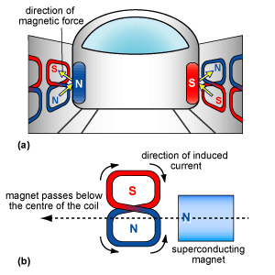Like in figure 14a, the magnetic pole in the lower half of the coil is the same as that of the magnet on the train whilst the upper half of the coil has an opposing pole. Both of these forces (the repulsion of the bottom and the attraction of the top of the coil) produces an upward force strong enough to overcome the weight of the train and lifts it at an impressive height of approximately 4 inches above the guideway [16]. However, a current can only be induced within these coils when the superconducting magnets are in motion. At low speeds, the current produced within these coils are inadequate in generating a repulsive force that is strong enough to support the weight of the train [22]. As a result, rubber wheels have been installed which are needed for travel until the train reaches a speed of roughly 140km/h after which the rubber wheels are no longer in contact with the guideway and are hidden [21].

Figure 14

Maglev Propulsion (EDS):

Unlike the EMS system, the magnets on an EDS train are not able to provide propulsion unless a separate propulsion system was provided. Thus, propulsion coils have also been installed along the sides of the guideway for acceleration and deceleration (figure 13). Like the levitation coils, the propulsion coils are made of metal but are active; meaning they are supplied by a source of energy [21]. Once the train is levitated, power is supplied to the propulsion coils to create a system of magnetic fields that use attraction and repulsion to move the train along the guideway. This is achieved by supplying an alternating current to the propulsion coils which produces perpetually varying magnetic fields such as those in figure 15.

*Figure 15:*

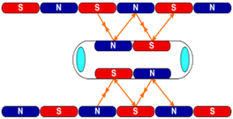To move the train forwards, the magnetic field of the area in front of the train has to be the opposite of the magnets installed in the front of the train which will create attractive forces between the guideway and the vehicle which will ‘pull’ the train. The magnetic field behind the train has to have the same polarity as those installed in the back of the train to produce repelling forces which will add a forward thrust to the train; acting as the ‘push’ force [23]. To slow down, the process is reversed, ‘pushing’ the front of the train and ‘pulling’ the back.

Advantages & Disadvantages of EMS & EDS Systems:

When choosing between two methods, it is crucial to weigh the advantages and disadvantages of each and evaluate them against each other.

|  |  |  |
| --- | --- | --- |
|  | **Electromagnetic Suspension** | **Electrodynamic Suspension** |
| **Advantages** | ·         EMS systems produce a far less intense magnetic field than EDS systems.  ·         EMS systems have proved to be adjustable for commercial use. EDS systems still have yet to do this.  ·         The Shanghai Maglev is currently fastest commercially available train; able to reach speeds of 431km/h. [24]  ·         Maglev uses less energy up to 30% than normal trains. [25]  ·         Because of lack of contact with the tracks, maintenance is low.  ·         Does not require wheels or a secondary propulsion method. | ·         Superconducting magnet can conduct electricity even after the power supply has been shut off.  ·         Can reach incredibly high speeds e.g. JR Central's L0 superconducting Maglev has reached 603km/h breaking world records and becoming the fastest train in the world.  ·         Maglev uses less energy up to 30% than normal trains. [25]  ·         Because of lack of contact with the tracks, maintenance is low.  ·         Has wheels which would be effective in emergency situations.  ·         Has proved to have a heavy load capacity through multiple tests. [15] |
| **Disadvantages** | ·         The maglev train requires a constant supply of power to work. In case of power failure, it has its own battery power supply which can last almost an hour.  ·         Guideways can be expensive to build, costing far more than a conventional railway line. The cost per kilometre for dual track was $43.6 million, including trains and stations for the Shanghai Maglev train.  ·         Separation between vehicle and guideway must be constantly monitored due to unstable nature of electromagnetic attraction. [15] | ·         The use of a superconducting magnet induces a high intensity magnetic field which could affect people with pacemakers and damage magnetic data storage devices such as credit cards.  ·         Guideways can be expensive to build, costing far more than a conventional railway line. The construction of the Chūō Shinkansen line is expected to cost $178 million per kilometre [25].  ·         Requires wheels at low speeds. This means that tracks also need to be suitable for wheels which could add extra costs.  ·         EDS systems rely on metals that have been super-cooled (e.g. using liquid nitrogen) close to absolute zero. This process can be very expensive. Requires magnetic shielding [14]. |

After assessing both the advantages and disadvantages of both maglev systems against each other, we have decided to use the EMS system. Although EMS is more expensive, as it produces a less intense magnetic field than those created on the EDS system, it does not affect those who have a pacemakers or damage magnetic data storage devices. Not only this, but EMS trains have already proven to be suitable for public use (as shown by the Shanghai Maglev Train and the Incheon Airport Maglev Train).

Maglev Vehicle Design:

Each train contains eight individual carriages with a capacity of 75 passengers.

*Figure 16: Design view with support struts used for bridges.*

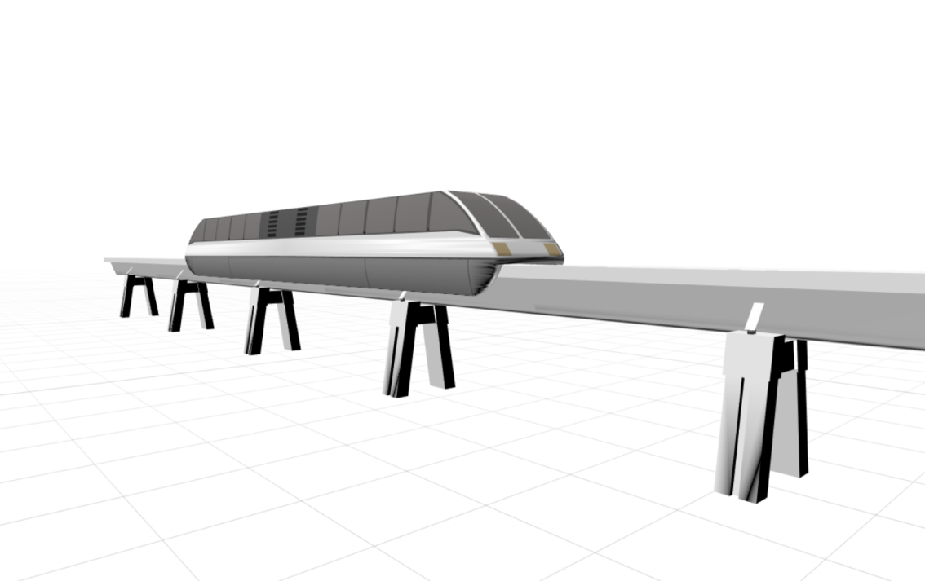

*Figure 17: Profile view with support struts used for bridges.*

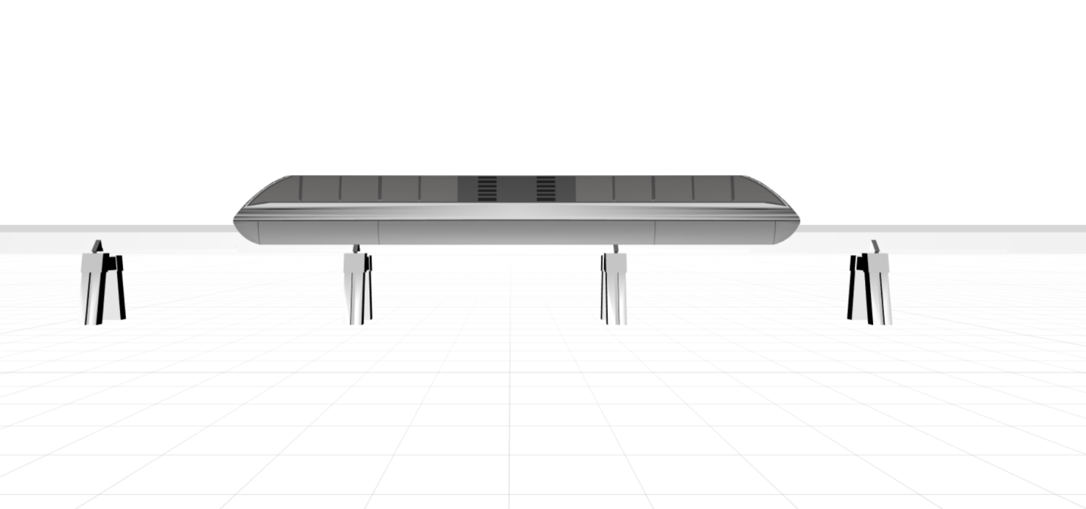

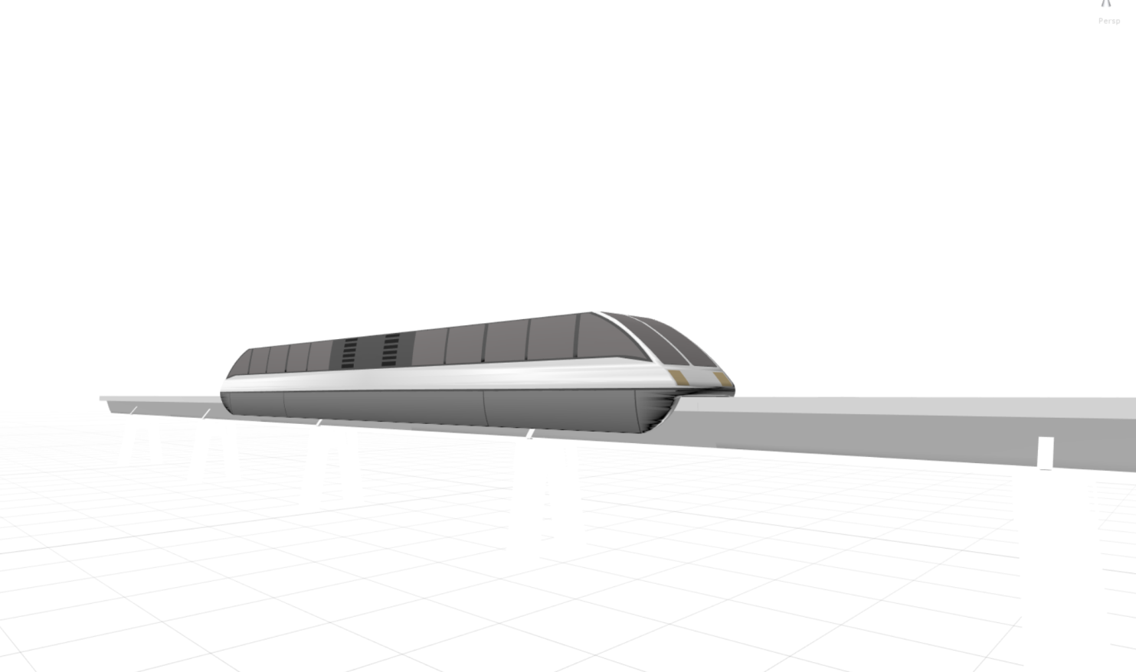

*Figure 18: Design view without support struts as proposed for the majority of the route.*

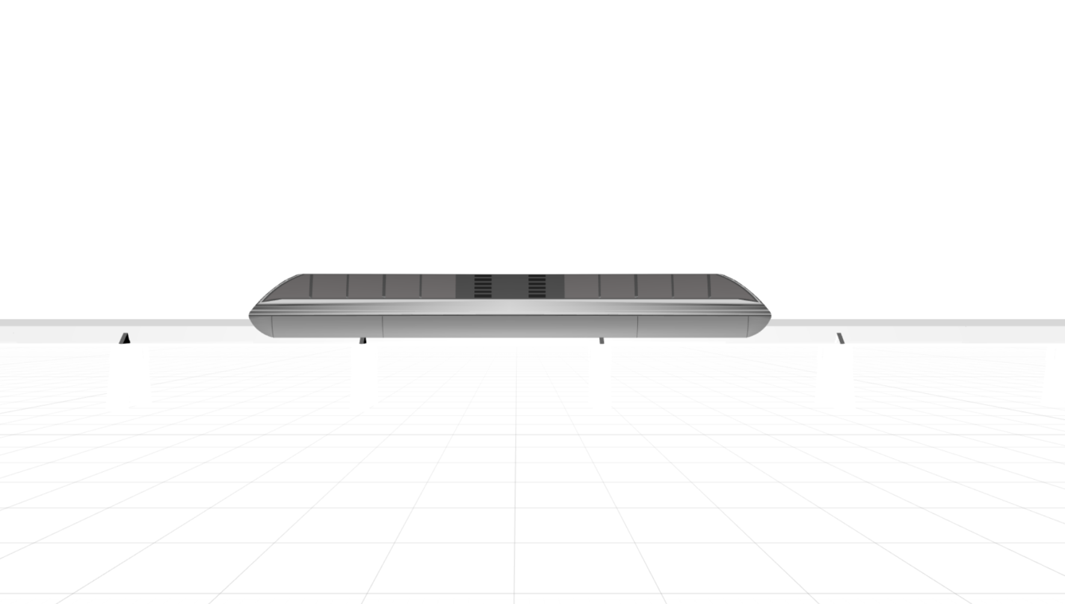

Trains rely on driver operation; however the Rail Traffic Management System recommends the optimum speed to the driver.

*CGI model created using Autodesk 3ds Max and provided by Transrapid for educational purposes.*

*Figure 19: Profile view without support struts used for bridges.*

Skytran Vehicle Design:

Skytran’s pods have a capacity of two passengers each as well as additional storage for luggage at the rear. The aerodynamic design of the pod reduces energy loss due to air resistance as well as mitigating issues concerning turbulence but cutting through the air.

*Figure 20:*

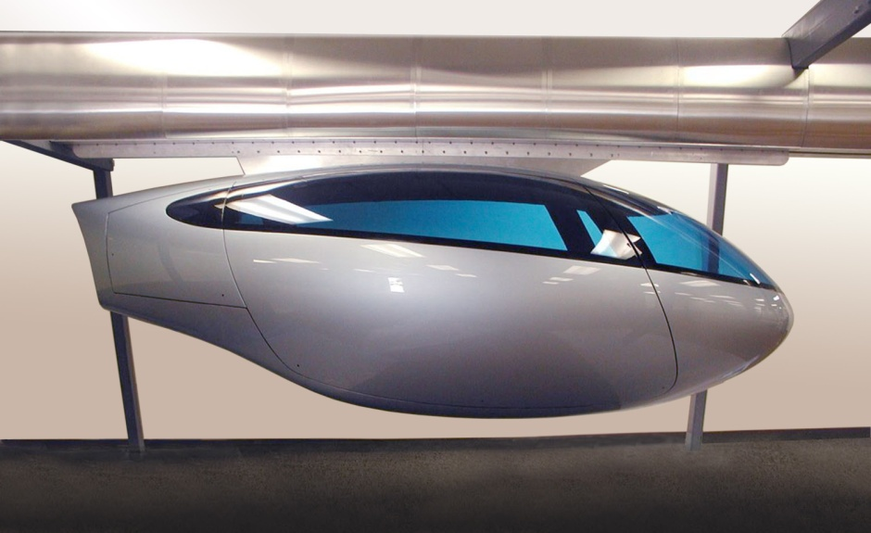All pods are computer controlled via an onboard computer communicating with a central mainframe. Using a principle similar to the Maglev’s traffic management system, the optimum speed and acceleration is relayed to the pod; however, commands are immediately enacted. In the event of an accident, pods are able to decrease speed and stop even before the accident is in sight.

*Figure 21: Prototype fibreglass SkyTran pod.*

**Costs and Timing:**

Considerations:

Vehicles:

We have 8 stations, at each station we will have 2 trains, one running clockwise and the other anti-clockwise. We are doing this to minimise the time the passengers have to spend in travel by taking the train with the shortest path to their particular destination. There are 75 seats per carriage and 8 carriages per train, consequently 600 passengers. This can fit the average demand between stations. However, the average people travelling from Gatwick to Heathrow is 1200 and vice versa. If the excess passengers have to wait for the next train, it would arrive in 9.14 minutes (5.24 minutes in the direction from Heathrow to Gatwick) and the journey time is 8.47 minutes, so they'll still reach in 20 minutes (see appendix **C**).

The next issue is from Heathrow to Luton and vice versa, the average demand is 850, but even if the excess wait for the next train, it will arrive in 3.68 minutes (3.25 in the direction from Luton to Heathrow) and the journey time is 10.41 minutes, which is within 20 minutes as well. This, and other issues regarding capacity, can be resolved if we ask passengers to book their train tickets with their airplane ticket.

Propulsion Systems:  
The propulsion is caused through magnets in the guideways attracting and repelling to pull and push the train. This cost includes such items as substation civil structures, magnets, and power systems.

Energy Supply:  
The electric current is supplied through the coils in the guideway control technology. This is for data transmission, vehicle location components, the emergency system, public information and address systems, and other monitoring and detection devices needed for safe and efficient operation.

Stations: Each station needs two platforms; one for clockwise and the other for anti-clockwise. We considered lighting, security measures, and areas for ticket sales, passenger information, station administration and baggage handling. The actual station design may be different in each place, as in with conventional trains but a rough estimate would be used.

Operations and Maintenance Facilities: The maintenance costs for the maglev are quite small as we minimise friction. However, there would be labour costs to maintain the interior of the train and manage all the functions of a public transport system. Also, repairing damage due to heat may be required when there are moving parts.

Right-of-Way and environmental issues:  
This would include the purchase of land, relocation assistance, demolition costs, etc. from the right-of-way estimates. Also, the cost of removal of hazardous material, purchasing greenfield sites and farmers’ land, conducting a proper ordnance survey of the land (investigating inclines, soil, etc.) and replacing habitats.

Capital Costs of the maglev rail:

An estimate extrapolated from the Colorado Department of transportation an estimate was achieved.

*Figure 22:*

Construction costs:

Vehicles £2,496,000,000

Propulsion and Energy System £125,000,000

Control Technology £159,000,000

Guideway Track £854,000,000

Operations and Maintenance £12,000,000

Right of way and environmental issues £386,000,000

Stations £112,000,000

Other £178,000,000

Construction support £40,000,000

**Total £4,362,000,000**

Operations cost of maglev according to results from the Rocky Mountain Rail Authority High‐Speed Rail Feasibility Study Business Plan

*Figure 23:*

Maintenance Cost per Mile per year:

Equipment Maintenance £6.97

Crew £4.28

Energy £1.94

Insurance £0.01

Track £15.13

Stations £9.43

Other £1.8

**Total Cost per mile £39.56**

Our track of maglev is 145.22 miles so the operational costs would be £5,744.90 per year. In twenty years the operational cost would amount to £114,898.

Capital Costs of the Skytran System:

According to SkyTran, their estimate is £ 7.2 million/km (see additional reading concerning SkyTran).This includes the aluminium guide way track, fibreglass vehicles (pods), and stations (every quarter mile).  This seems reasonable as according to an in-depth analysis by *advancedtransit.org*

The total cost of a PRT track and associated civil engineering works, for typical installations is found to average $8.7 million (£7 million) per mile. We are using 10.315 miles amount of track. Therefore, the total cost is £1,682,712,000. However, it may cost more if you consider operational costs and the cost of land use, etc. On the other hand these costs are not as much compared to the maglev, as it is a smaller computerised system, built on the side of the road. We can also factor out the cost of a station every quarter mile as we just have one station (London city airport) connecting it to Aveley station on the maglev ring-rail. However, an added £10,000 should be taken into account for the minor issues that may not have been spotted.  
  
So we have to recover £6,044,836,898 in twenty years. If 9420 people use the system on average per hour, meaning 169,560 people will use it per day if we operate for 18 hours a day. This means 61,889,400 will use it a year. Therefore, 1,237,788,000 will use it in 20 years. This means the price of one ticket must be minimum £4.89 on average. So, if we price the ticket at £10 per person, we will recover the costs in approximately 6 years. Therefore, in 20 years we will make a profit of £6,333,043,102.

Procurement of Hardware:

Maglev:

Private contractors will provide the hardware and labour needed for the: rail, carriages, testing etc.; all contributing to additional time. I will assume that the hardware will be received within a reasonable time following a request.

Examples of Contractors:

‘DTK’

(<http://www.railway-technology.com/contractors/infrastructure/dtk/>)

‘‘Larsen and Toubro’

(<http://www.railway-technology.com/contractors/infrastructure/larsen/>)

Larsen and Toubro’ may be used for measuring, monitoring and constructing the necessary infrastructure for the project.

According to Roger Ford, technology editor at Modern Railways**,** [27]an estimated one mile of track can be placed per day after the track foundations and terrain work has been completed (based on data for HS2). Environmental impact assessments, CPOs, and consulting the public [27] are the most delaying and variable features prior to construction – HS2’s construction has been delayed by these factors [27]. After this has been sorted, the track can be laid relatively quickly.

Skytran:

Since there are no current factories in the UK that can build SkyTran equipment, procurement time will be increased. However, In an email thread with Jane D. Stepak of Skytran, operations could be set up in the UK if there is sufficient demand within the next 10 years.

Rail Construction Timetable:

Government and Council consultation will impact the time significantly:

* Environmental impact assessments will stagnate development.
* Compulsory Purchase Orders (CPOs) will take time due to negotiation, appeals, and waiting times
* Approximately 1 year is needed to lay the track.

Schedule:

Schedule timetable is set after negotiation and legal issues have been settled as well as the time required for terrain alteration for the maglev track.

Procurement schedule:

*Figure 24*

|  |  |  |
| --- | --- | --- |
| Years (within) | 0.5 to 1 | 1 to 3 |
| Hardware | Time of receiving most of the hardware from contractors (fences, systems etc.). | SkyTran and Maglev hardware – including rail and carriages. |

Construction:

Environmental impact assessments, CPOs, and consulting the public [27] are the most delaying features prior to construction – HS2’s construction has been delayed by these factors [27]. After this has been sorted, the track can be laid relatively quickly.

*Figure 25*

|  |  |
| --- | --- |
| Years (within) | Up to 1 |
| Finalisation of Construction | Fences, electrification, power supply etc..  SkyTran and Maglev tracks can be laid in a little less than one year (10-11 months). |

**Total Time:**

Procurement Time ≈ 3 years

Time Prior to Construction ≈ 3 years

Finalisation of Construction ≈ 1 year

Health and Safety Risk Assessments (and additional checks on the system) ≈ 1 year

*An 8 to 10 Year Estimate (due to expected delays)*

Appendix:

Appendix Contents:

Appendix A: Hyperloop 32

Appendix B: Preliminary Land Cost Calculations 33

Appendix C: Maglev Speed and Time Calculations 34

Appendix D: Pan-London SkyTran Routes 35

Appendix E: Maglev Carriage Capacity Calculations 40

Appendix F: Heathrow Expansion 41

Appendix G: Incline Heatmap 43

Appendix H: SkyTran Required Carriages 44

Appendix A: Hyperloop

Hyperloop – Rejected low pressure rapid transit system:

The concept of the Hyperloop involves sending specifically designed transport capsules through a continuous and de-pressurised steel tube; eliminating a large portion of the drag force experienced by conventional open air trains. Linear induction motors located along the tube would accelerate and decelerate the capsule.

Problems arise in the tube’s construction however. Assuming that the Hyperloop follows the same path as the maglev ring-rail, a huge amount of air will need to be pumped out as well as maintaining the low pressure inside the tube afterwards.

Track/Tube length: 233.71 km

Tube Diameter: ˜ 2m

Internal pressure: 0.001 atm [28]

Using these figures, it can be calculated that 733,000 m3  of air must be pumped out and constantly maintained at 0.001atm – therefore introducing very large maintenance overheads.

Π x (2/2)2 x 233.71 x 103 x 0.999 = 733,487.4 m3 ≈  733,000 m3

In comparison, the world’s largest vacuum chamber has a volume of 22,653 m3, 3% of the estimated volume of the rejected system [29], highlighting severe impracticalities of Hyperloop.

Additionally, the Hyperloop would have be well guarded during at all times due to the catastrophic impact if the tube were to be breached leading to the sudden pressurisation of the tube resulting in dangerous turbulence.

Appendix B: Preliminary Land Cost Calculations

Preliminary land cost calculations:

September 2015 (average) farmland cost – £8306/4046.86metres^2 (£8306/acre) [30]

The maglev track gauge is 1.53 metres [11].

(1.53m x 2m) + 2m (gap) + 5m = 10.06 metres ≈ 10 metres.

Length of Maglev track is 223,670m. Area of track is 10m x 223,670m = 2,236,700m^2.

2,236,700m^2/4046.86m^2 = 552.70

552.70 x £8306 = £4,590,726.20 estimate for **whole** track

However, this does not consider the depreciation of property and land cost adjacent to the track and how this will increase the cost of compensation towards the property owners.

Statement Of Case [32] – this justifies the reasons for the CPO.

Appendix C: Maglev Speed and Time Calculations

Maglev speed and time calculations:

Acceleration 1.5 ms-2

Max speed: 430 km/h = 119.5 ms-1 [15]

To reach max speed takes 79.6 seconds at acceleration 1.5ms-2

Assuming linear acceleration, average speed during this time is 59.75 ms-1, so it takes a distance of 4756m (59.75 x 79.6 s)

**32km Gatwick to Woking station**

*32000m – 2 x* 4756m *=* 22488m

22488m *at 119.6ms-1*

22488m */ 119.6ms-1 = 188s*

*188s + 2 x* 79.6 *s = 287.2 seconds from Gatwick to Woking*

*4.79 minutes.*

**17km Woking to Heathrow**

*17000m - 2 x 4757m = 7486m*

*7486m / 119.6 = 61.6s*

*61.6s + 2 x 79.6s = 220.8s*

*220.8s = 3.68 minutes*

**31.29km Heathrow to Hemel Hempstead station**

*31290m – 2 x 4757m = 21776m*

*21776m / 119.6 = 182.1s*

*182.1 + 2x 79.6 = 314.3s*

*314.3s = 5.24 minutes*

**13.19km Hemel Hempstead to Luton**

*13190m – 2 x 4757m = 3678m*

*3678m at 119.6 ms-1*

*3678 / 119.6 = 30.75s*

*30.75 + 2 x 79.6 = 189.95s*

*189.95s = 3.17 minutes*

**13.8km to Luton to Stevenage Station**

*13800m – 2 x 4756m = 4288m*

*4288 m at 119.6 ms-1*

*4288 / 119.6 = 35.85s*

*35.85s + 2 x 79.6s = 195.05s*

*195.05s = 3.25 minutes*

**28.74km Stevenage station to Stansted**

*28740m – 2 x 4756m = 19228m*

*19228m / 119.6 = 160.8s*

*160.8s + 2 x 79.6s = 320s*

*5.33 minutes*

**40.98km Stansted to Aveley station (skytran station to London City)**

*40980m – 2 x 4756m = 31468m*

*31468m / 119.6 = 263.11s*

*263.11s + 2 x 79.6s = 422.31s*

*7.04 minutes*

**55.99km Aveley station to Gatwick**

*55990m – 2 x 4756m = 46478m*

*46478m / 119.5 = 388.94s*

*388.94 + 2 x 79.6s = 548.14s*

*9.14 minutes*

Appendix D: Pan-London SkyTran Routes

Appendix D – Part i

Route 1: Aveley to City Airport:

**SUCCESSFUL ROUTE**

Route follows the southern side of the A13 until it passes Barking Reach Power Station. Route meets the main road Alfred’s way.

Skytran has an estimated maximum speed of 240 kph (66.67 ms-1) – [14], however it is unlikely that this speed will be reached in an urban transit system. As an estimate, the average speed of the journey would be roughly 30ms-1.

16,600m / 30 = 533.3s = 9.2 minutes

Unlike a train, Skytran is able to accelerate at a faster rate due to how the passengers are seated but should not exceed more than 0.5G (4.9ms-2) for passenger comfort and safety.

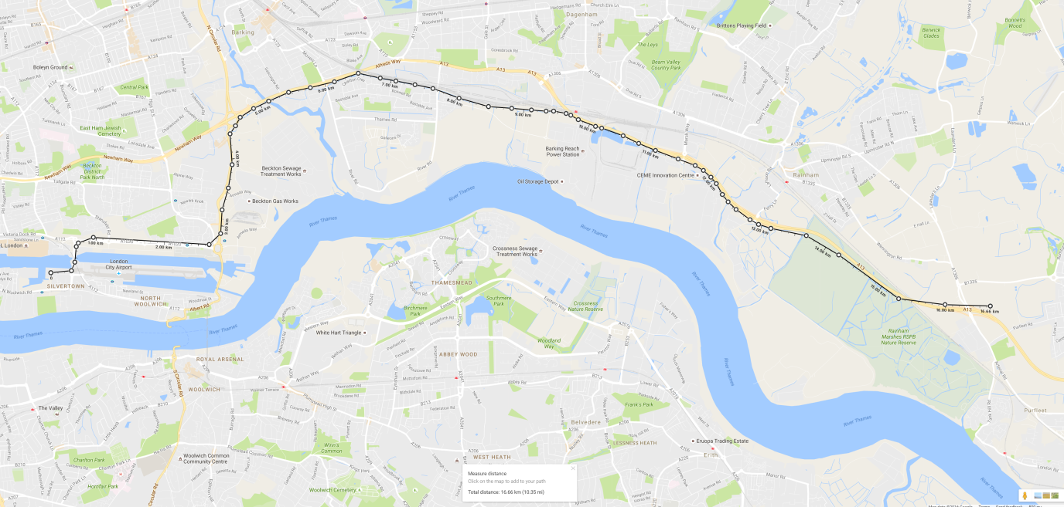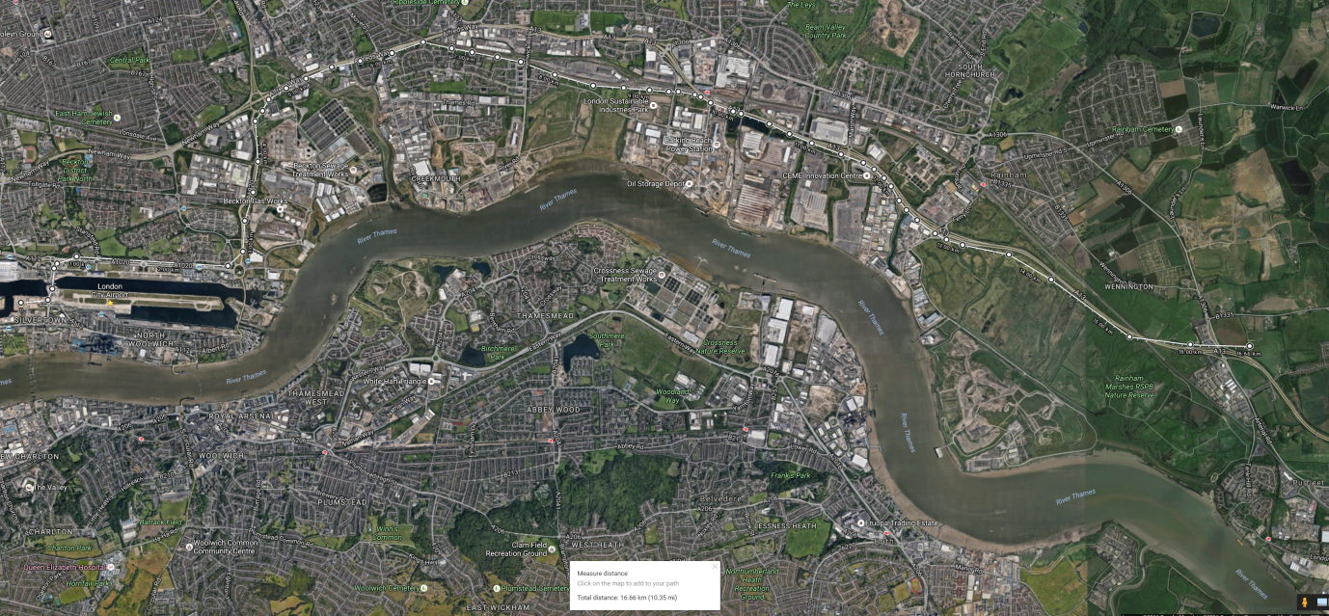

Appendix D – Part ii

Route 2: Aveley to City Airport:

**REJECTED DUE TO COST GREATER COST COMPARED TO ROUTE 1**

Route 2 is an alternative to route 1. It is 0.93km shorter in its length but the straighter path it takes would allow the carriage to reach higher speeds.

As an estimate, the average speed of the journey would be roughly 35ms-1.

15,730m / 35 = 450s = 7.5 minutes.

This would be more costly to construct due to the river-spanning sections and the fact that some intrusion to homes is expected.

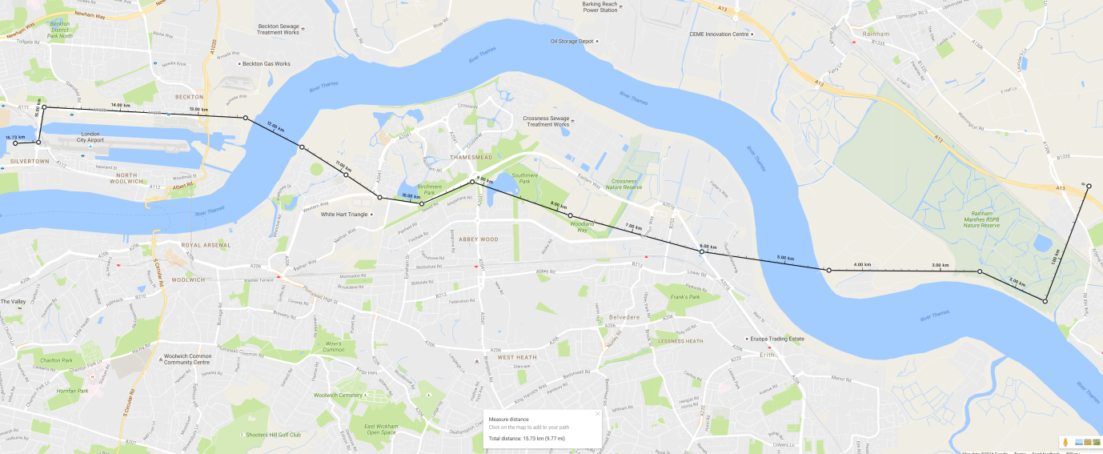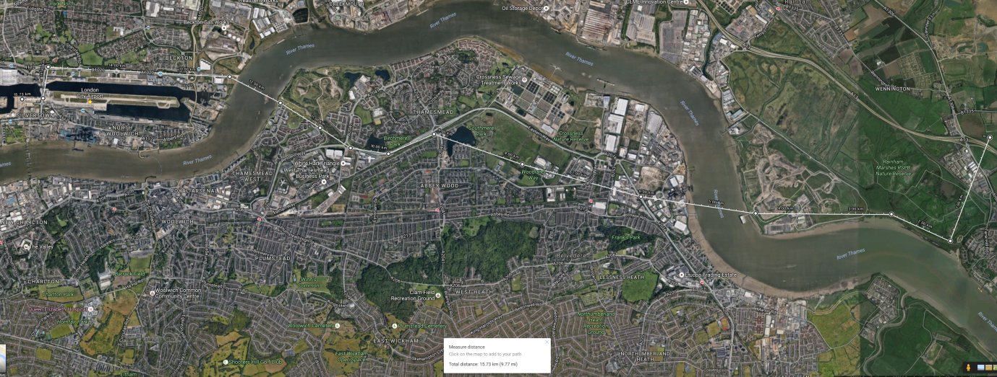

Appendix D – Part iii

Route 3: Heathrow to City Airport:

**SUCCESSFUL ROUTE**

•          Starts at Heathrow

•          Follows Great West Road until it reaches the m4

•          Keeps following the main road after the m4.

•          Turns to meet the Thames after passing Buckingham Palace

•          Follows North side of The Thames to meet City airport, cutting behind the Isle of Dogs via the A1261

As an estimate, the average speed of the journey would be roughly 50ms-1 (allowing for high speed alongside the motorway)

40,690 / 50 = 813.8s = *13.56 minutes.*

Although it would be an expensive endeavour, it is a relatively direct route which follows main roads and attempts to avoid residential areas.

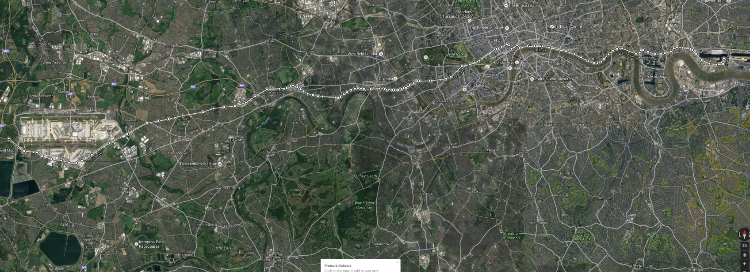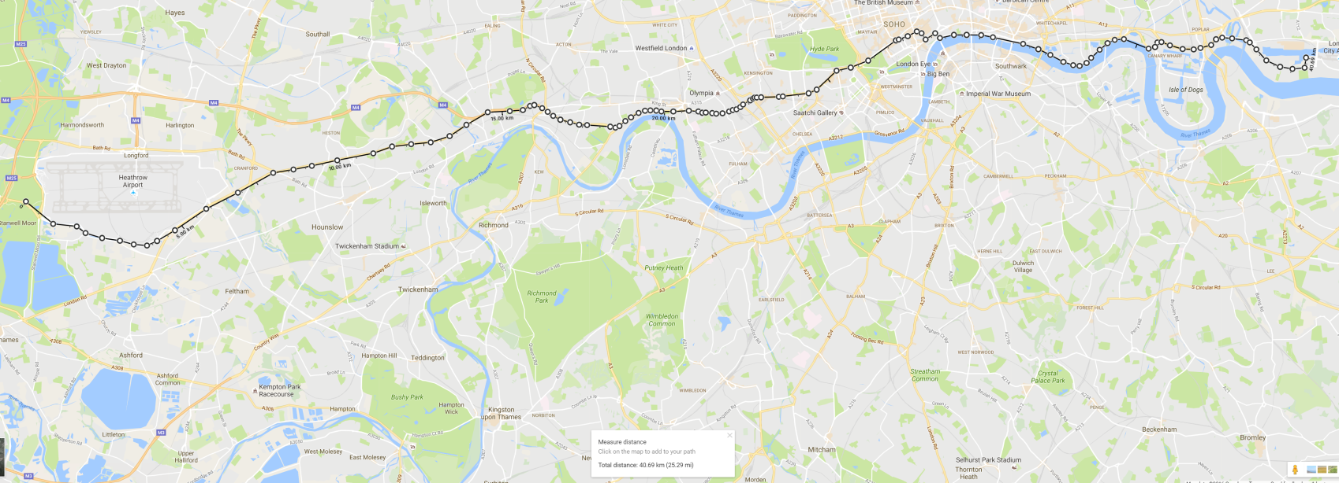

Appendix D – Part iv

Route 4: Stansted to City Direct:

**REJECTED DUE TO SUFFICIENCY OF MAGLEV RAIL SPEED**

Route 4 is a direct route that follows the M11 to avoid a large impact on nearby farmland.

Route 4: Stansted to City Direct.

Route 4 is a direct route that follows the M11 to avoid a large impact on nearby farmland.

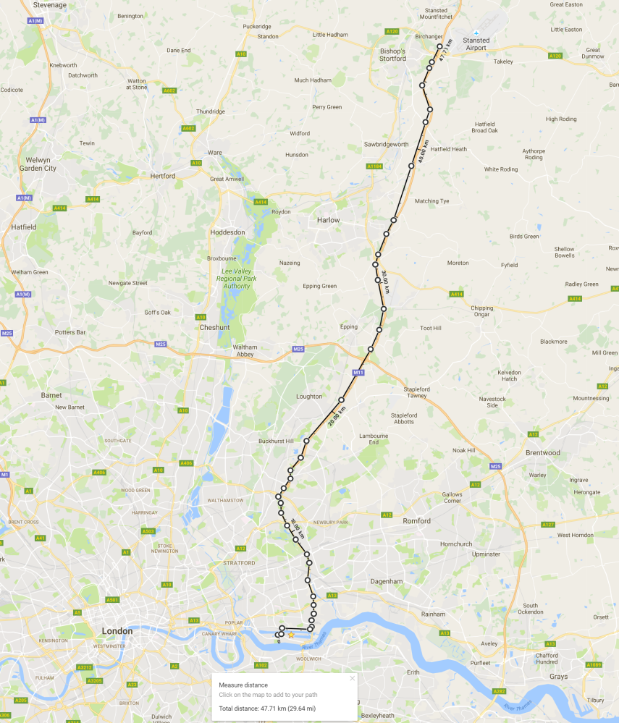

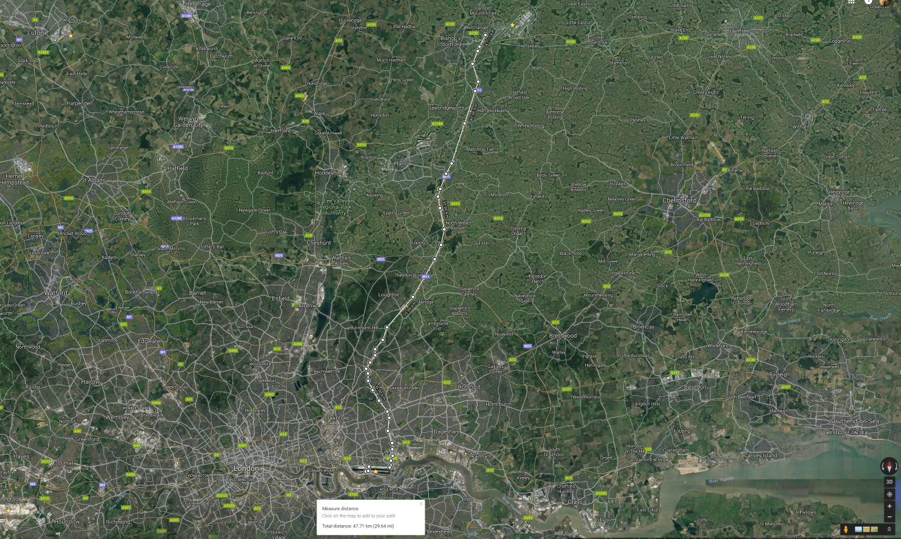

Appendix E: Maglev Carriage Capacity Calculations

**Calculations assume that every passenger makes a full circuit. Although this will not happen in reality, it ensures that the service will always be operational and trains have seats to spare.**

75 seats per carriage, 8 carriages per train.

75 x 8 = 600 passengers per train.

Total 6 minutes waiting time on a full circuit. Full circuit time = 41.64 + 6 = 47.64 minutes

The peak amount of passengers between any two airports is 1200 per hour.

Sum peak clockwise passengers:

1200 + 1100 + 670 + 330 + 780 + 220 + 510 + 310 = 5120

Sum peak anti clockwise passengers:

1200 + 1100 + 780 + 510 + 310 + 220 = 4120

Train minimum transportation capability per hour:

(600/47.64) x 60 = 755 people

Clockwise trains needed:

5120 / 755 = 7 trains

Anti-clockwise trains needed:

4120 / 755 = 6 trains.

Three additional trains should be retained in storage adjacent to Gatwick, Heathrow, and Luton (the three largest airports) in the event that either any currently operational trains are damaged or may require governmental/regulatory inspection;  enabling the system to maintain functionality.

In addition, despite satisfying the demand of peak times, the minimum trains required do not provide any additional benefit. A train located at each station on the clockwise and anti-clockwise ring (totalling 16 trains) will not only increase passenger capacity for the future but allow for greater income generation.

Appendix F: Heathrow Expansion

Heathrow Expansion

The Heathrow Expansion, predicted to be fully operational by 2026 (if approved), proposes the construction of a 3500 m long third runway at Heathrow costing an estimated £17.6 billion [33]. The plan involves tunnelling a 14-lane stretch of M25 underneath the runway to be built ‘without disruption to the present motorway [34] to fulfil its promise of providing up 740,000 flights a year [35]. Nonetheless, the expansion, though pledging a myriad of ‘*advantages*’, has had many setbacks and oppositions from a variety of groups. The Government strongly argues that the major advantage of the expansion of Heathrow is that it “*would bring in net benefits of around £5 billion*” and increasing the capacity of Heathrow would allow for significant potential economic benefits. However, an analysis of the economic benefits and costs of Heathrow would prove otherwise.

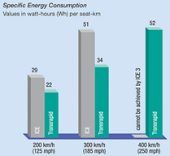Firstly, the Government applies a monetary estimation to the project’s climate costs; approximating it to £4.8 billion. They used a figure of £19 for the damage from a tonne of carbon dioxide emitted now due to strong climate change policies placed by the world’s Governments to prevent the worst possible climate change damage. This is far lower than the figure used in the Stern Review of £53 per tonne­—a figure that itself is an underestimate as it only includes financial estimates for certain types of climate change impact and is based on models established from science several years old. The Stern Review is unambiguous that its values are “regarded as rather conservative estimates of costs”. Saying this, a more appropriate value of £14 billion should be used instead of the £4.8 billion stated [36] [37] [38]. The £9 billion increase is enough to turn the expansion into a net cost of £3 billion. Applying such a low value means that climate change is given lower influence and is therefore actively preventing the strong policies of climate change made by the world’s Governments.

This growth in air pollution will undoubtedly affect the poorest countries who are least able to adapt to or prevent climate change impacts. In contrast, the bulk of the benefits are to ‘generated users’ beyond 2030 who take additional flights—those who are already wealthy—getting slightly cheaper flights. Moreover, 750 homes are subject to compulsory purchase [33]; all ethical issues that are hidden under estimated ‘generated user’ and producer benefits.

As climate change is growing more substantial, it is imperative that it is weighted heavily in the planning for projects such as this. Alongside carbon emissions, noise and air pollution are notable effects that must also be considered. Maglev systems use considerably less energy compared to a traditional InterCity Express train (ICE) at both 200kmph and 300kmph (as shown on Graph 1). It does consume more energy at higher speeds but these are at speeds which the ICE cannot achieve. Furthermore, the EDS train would produce less noise pollution due to its lack of contact with any rails and to reduce visual impact on surrounding locals, the guideways can be ‘hidden’ behind small hills to make it appear as if the guideways aren’t there. To further reduce noise pollution, as our Maglev system is a ring system capable of travelling from one airport to another in less than 20 minutes, if possible, certain airports can be assigned certain locations (e.g. Heathrow can focus its flights to only places in North or South America). This will not only reduce the pressure from these airports but flights can also be redirected so they do not fly over London. This also allows for more possible locations, expanding the network of destinations which in turn may initiate a growth in tourist numbers (due to better access) thus making it a benefit for the economy.

An argument was also made where the price of flights would decrease along with the decrease in oil prices. The DfT assume that oil prices will “*fall from $64 per barrel in 2006 to $53 per barrel in 2030*” [39]. Contradicting this, the price has since gone over $100 since this report has been published. With the increasing price of oil, the Government’s estimated cost decrease of short and long haul flights would not be as great. The maglev system we have created incorporates maglev trains and SkyTran which are both forms of low energy consumption transportations. As well as having less effect on carbon emissions, the system’s seldom use of oil means carbon emissions cost is lower therefore overall cost is lower for both passengers and those responsible for the upkeep of the Maglev system.

The Government estimates delay reduction benefits at Heathrow and converts them into monetary values yet they do no similar application to the extra delays and carbon impacts from the construction of the runway as well as from the extra road congestion. If our high-speed ring system was made public, congestion in and around London would be lowered and pressure on the London Underground would also be lowered.

The Heathrow Expansion project has been fighting for approval since 2007 and this is understandable considering the substantial flaws within its report, most evident in its climate change section. They apply monetary values to each factor of the project promising a considerable ‘net economic cost’ yet upon revaluation, this benefit suddenly becomes a ‘net economic cost’. Our high-speed ring system would not only alleviate a lot of congestion and noise pollution from London but, by appointing airports to certain locations and perhaps making it a public transport system, it would eliminate the need for the Heathrow Expansion.

Appendix G: Incline Heatmap

Maglev trains are capable of climbing a 4 percent gradient while maintaining maximum operational speed (in our case 450 kmh-1) but with a nominal impact on power consumption. [40]

Despite this, we should attempt to mitigate inclines above 2%.

Simplified Heat map diagram showing the gradient along the Maglev Rail Loop [41]

Green: <1%                     Yellow: 1% - 2%             Orange: > 2%

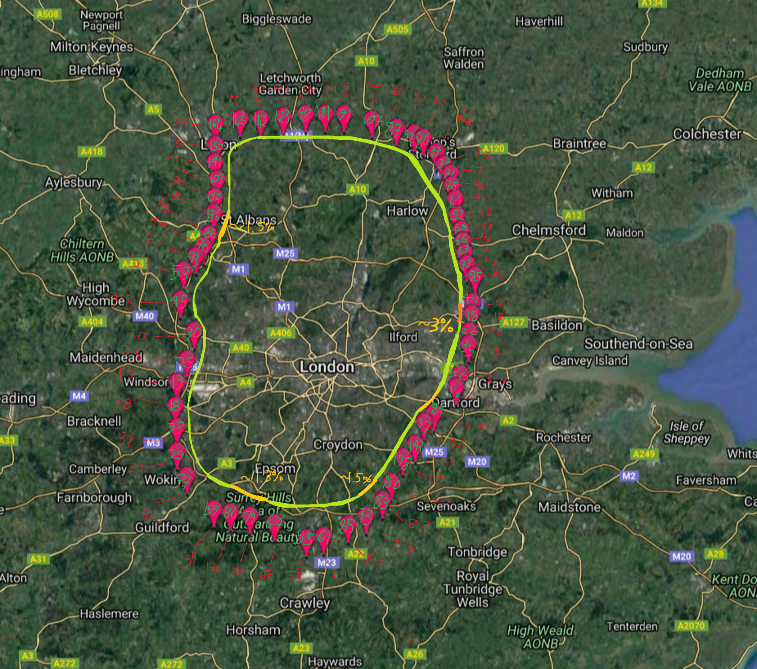

Appendix H: SkyTran Required Carriages

Skytran Required Carriages:

*Carriages needed:*

*2 people per carriage.*

*A double rail is needed to bring back carriages.*

***To Heathrow Skytran station***

Heathrow – City peak 670

Luton-City peak 220

Total: 890 per hour peak

13.56 min to City airport (appendix **D**)

27.14 min until carriage is back at Heathrow.

Round to 30 minutes to take into account potential delays.

890 people  / 2 per carriage= 445 carriage uses per hour.

445 / (60/30) = 222.5 carriages needed ≈ 223 carriages needed in peak hour.

***To Aveley Skytran station (Using Route 1)***

Gatwick – City peak 310

Stansted – City peak 220

Total: 530 per hour peak.

9.2 min to City Airport. (appendix **D**)

18.2 min until carriage is back at Heathrow.

Round to 20 minutes to take into account potential delays.

530 people / 2 per carriage = 265 carriage uses per hour.

265 / (60 / 20) = 88.3 carriages needed ≈  84 Carriages needed in peak hour.

*References:*

[1] Communities and Local Government (2004) *Compulsory Purchase and Compensation*, Valuation Office Agency (VOA): Communities and Local Government. Available at:

<https://www.gov.uk/government/uploads/system/uploads/attachment_data/file/571449/booklet1.pdf>

[2] Communities and Local Government (2012) *National Planning Policy Framework,* Available at: [*https://www.gov.uk/government/uploads/system/uploads/attachment_data/file/6077/2116950.pdf*](https://www.gov.uk/government/uploads/system/uploads/attachment_data/file/6077/2116950.pdf)

[3] Designing Buildings (2017) *Green Belt,* Available at: [*https://www.designingbuildings.co.uk/wiki/Green_belt*](https://www.designingbuildings.co.uk/wiki/Green_belt)

[4].Designing Buildings  (2017) *Brownfield Land,* Available at: [*https://www.designingbuildings.co.uk/wiki/Brownfield_land*](https://www.designingbuildings.co.uk/wiki/Brownfield_land)

[5]. BBC (2014) *Brownfield and Greenfield sites,* Available at: [*http://www.bbc.co.uk/schools/gcsebitesize/geography/urban_environments/urbanisation_medcs_rev5.shtml*](http://www.bbc.co.uk/schools/gcsebitesize/geography/urban_environments/urbanisation_medcs_rev5.shtml)

[6]. (2017) *Find protected areas of countryside,* Available at: [*https://www.gov.uk/check-your-business-protected-area*](https://www.gov.uk/check-your-business-protected-area)

[7] Civil Aviation Authority (2015) *Aviation noise information,* Available at: [*https://www.caa.co.uk/Environment/Environmental-information/Information-by-environmental-impact/Noise/Aviation-noise-information*](https://www.caa.co.uk/Environment/Environmental-information/Information-by-environmental-impact/Noise/Aviation-noise-information)

[8] US Patent Office - Applicant: Douglas. J (2015) *US Patent & Trademark Office, Patent Full Text  
and Image Database,* Available at:  
[*http://patft.uspto.gov/netacgi/nph-Parser?Sect1=PTO1&Sect2=HITOFF&d=PALL&p=1&u=%2Fnetahtml%2FPTO%2Fsrchnum.htm&r=1&f=G&l=50&s1=D329028.PN.&OS=PN/D329028&RS=PN/D329028*](http://patft.uspto.gov/netacgi/nph-Parser?Sect1=PTO1&Sect2=HITOFF&d=PALL&p=1&u=%2Fnetahtml%2FPTO%2Fsrchnum.htm&r=1&f=G&l=50&s1=D329028.PN.&OS=PN/D329028&RS=PN/D329028)

[9] Leanna Garfield (2016) *A self-driving monorail is being built to chop  
2-hour commutes down to 10 minutes,* Available  
at: [*http://uk.businessinsider.com/skytran-flying-pods-will-launch-in-nigeria-2015?r=US&IR=T/#skytrans-system-will-then-send-passengers-automaticallyto-their-destinations-if-the-pod-needs-to-stop-at-a-station-it-will-move-to-another-rail-so-that-the-one-behind-it-can-pass-the-pods-theoretically-never-need-to-stop-for-traffic-12*](http://uk.businessinsider.com/skytran-flying-pods-will-launch-in-nigeria-2015?r=US&IR=T/#skytrans-system-will-then-send-passengers-automaticallyto-their-destinations-if-the-pod-needs-to-stop-at-a-station-it-will-move-to-another-rail-so-that-the-one-behind-it-can-pass-the-pods-theoretically-never-need-to-stop-for-traffic-12)

[10] (2017) *Shanghai Maglev Train,* Available at: [*https://en.wikipedia.org/wiki/Shanghai_Maglev_Train*](https://en.wikipedia.org/wiki/Shanghai_Maglev_Train)

[11]  Nidirect  *Environmental Noise,* Available at: [*https://www.nidirect.gov.uk/articles/environmental-noise*](https://www.nidirect.gov.uk/articles/environmental-noise)

[12] (2017) *Shanghai-Hangzhou Maglev, China,* Available at: [*http://www.railway-technology.com/projects/shanghai-maglev/*](http://www.railway-technology.com/projects/shanghai-maglev/)

[13] Network Rail (2017) *European Rail Traffic  
Management System (ERTMS),* Available  
at: [*http://archive.nr.co.uk/aspx/12275.aspx*](http://archive.nr.co.uk/aspx/12275.aspx)

[14] (2016) *Maglev Comparison Overview,* Available at: [*http://www.skytran.com/maglev/*](http://www.skytran.com/maglev/)

[15]  (2017) *Maglev,* Available at: [*https://en.wikipedia.org/wiki/Maglev#Tracks*](https://en.wikipedia.org/wiki/Maglev#Tracks)

[16] EAB2083 Electromagnetics Theory (2014) *Maglev  
Suspension Systems,* Available at:  
[*http://emt18.blogspot.co.uk/2008/10/maglev-suspension-systems.html*](http://emt18.blogspot.co.uk/2008/10/maglev-suspension-systems.html)

[17]  SwissRapide AG (2017) *Maglev Rail,* Available at: [*http://swissrapide.com/htm/e_magnetbahn.htm*](http://swissrapide.com/htm/e_magnetbahn.htm)

[18] Lindsey Caldwell (2015) *Japan’s new maglev  
bullet train is now the fastest in the world,* Available at: [*https://www.slashgear.com/japans-new-maglev-bullet-train-is-now-the-fastest-in-the-world-22380159/*](https://www.slashgear.com/japans-new-maglev-bullet-train-is-now-the-fastest-in-the-world-22380159/)

[19]  Ma Sau-ying, Tong Shiu-sing (2000) *Frontiers of Physics: Maglev,* Available at: [*http://www.hk-phy.org/articles/maglev/maglev_e.html*](http://www.hk-phy.org/articles/maglev/maglev_e.html)

[20]  EAB2083 Electromagnetics Theory (2014) *Maglev Suspension Systems,* Available at: [*http://emt18.blogspot.co.uk/2008/10/magnetic-levitation.html*](http://emt18.blogspot.co.uk/2008/10/magnetic-levitation.html)

[21] (2015) *MAGLEV The flying train,* Available at: [*http://www.supraconductivite.fr/en/index.php?p=applications-trains-maglev-more*](http://www.supraconductivite.fr/en/index.php?p=applications-trains-maglev-more)

[22] (2017) *Electrodynamic suspension,* Available at: [*https://en.wikipedia.org/wiki/Electrodynamic_suspension#Trains*](https://en.wikipedia.org/wiki/Electrodynamic_suspension#Trains)

[23] EAB2083 Electromagnetics Theory (2014) *Maglev  
Suspension Systems,* Available at:  
[*http://emt18.blogspot.co.uk/2008/10/maglev-propulsion.html*](http://emt18.blogspot.co.uk/2008/10/maglev-propulsion.html)

[24] Cynthia Drescher (2016) *The 10 Fastest  
Trains in the World,* Available  
at: [*http://www.cntraveler.com/stories/2016-05-18/the-10-fastest-trains-in-the-world*](http://www.cntraveler.com/stories/2016-05-18/the-10-fastest-trains-in-the-world)

[25] Chan Jeon (2009) *Physics of Maglev Train,* Available at: [*http://ffden-2.phys.uaf.edu/212_spring2011.web.dir/Chan_Jeon/bibliography.html*](http://ffden-2.phys.uaf.edu/212_spring2011.web.dir/Chan_Jeon/bibliography.html)

[26] HS2 (2013) *The Economic Case For HS2,* Available at:<https://www.gov.uk/government/uploads/system/uploads/attachment_data/file/365065/S_A_1_Economic_case_0.pdf>

[27] Tom de Castella and Kathryn Westcott (2013) *HS2: 20 reasons why it can take 20 years to build a railway,* Available at: [*http://www.bbc.co.uk/news/magazine-21231044*](http://www.bbc.co.uk/news/magazine-21231044)

[28] SpaceX (2013) *Hyperloop Alpha,* Available at: [*http://www.spacex.com/sites/spacex/files/hyperloop_alpha-20130812.pdf*](http://www.spacex.com/sites/spacex/files/hyperloop_alpha-20130812.pdf)

[29] NASA (2014) *Space Power Facility,* Available  
at: [*https://facilities.grc.nasa.gov/spf/*](https://facilities.grc.nasa.gov/spf/)

[30] Jez Fredenburgh (2015) 'Farmland values slow while arable land prices start to fall', *Farmers Weekly,*. . Available at: [*http://www.fwi.co.uk/business/farmland-values-slow-while-arable-land-prices-start-to-fall.htm*](http://www.fwi.co.uk/business/farmland-values-slow-while-arable-land-prices-start-to-fall.htm)

[31] [MagnetBahn (2016) *Maglev Dimensions,* Available at:](https://en.wikipedia.org/wiki/Shanghai_Maglev_Train) [*http://magnetbahnforum.de/index.php?en_faf_transrapid_sha*](http://magnetbahnforum.de/index.php?en_faf_transrapid_sha)

[32] Communities and Local Government (2004) *Compulsory Purchase and Compensation*, Valuation Office Agency (VOA): Communities and Local Government. Available at:<https://www.gov.uk/government/uploads/system/uploads/attachment_data/file/571449/booklet1.pdf>

[33] Tim Bowler (2016) *Heathrow Airport expansion: Why is it taking so long?,* Available at: [*http://www.bbc.co.uk/news/business-35011620*](http://www.bbc.co.uk/news/business-35011620)

[34]Gwyn Topham (2014) *Heathrow bids to tunnel M25 under third runway,* Available at: [*https://www.theguardian.com/environment/2014/may/13/heathrow-tunnel-m25-under-third-runway*](https://www.theguardian.com/environment/2014/may/13/heathrow-tunnel-m25-under-third-runway)

[35]Heathrow (2015) *Heathrow - Our Proposal,* Available at: [*http://www.heathrow.com/company/company-news-and-information/airports-commission/our-proposal*](http://www.heathrow.com/company/company-news-and-information/airports-commission/our-proposal)

[36] Table 4.3 page 79 of Department for Transport document, 2007. Air passenger Demand and CO2 forecasts. November, Dft.

[37]Department for Transport (2007) *UK Air Passenger Demand and CO2 Forecasts,* Available at: [*http://webarchive.nationalarchives.gov.uk/+/http://www.dft.gov.uk/pgr/aviation/environmentalissues/ukairdemandandco2forecasts/airpassdemandfullreport.pdf*](http://webarchive.nationalarchives.gov.uk/+/http:/www.dft.gov.uk/pgr/aviation/environmentalissues/ukairdemandandco2forecasts/airpassdemandfullreport.pdf)

[38] Pages 125-129 of the main Heathrow consultation document

[39] Department for Transport document section 2.29

[40] Chan Jeon (2009) *Physics of Maglev Train,* Available at: [*http://ffden-2.phys.uaf.edu/212_spring2011.web.dir/Chan_Jeon/bibliography.html*](http://ffden-2.phys.uaf.edu/212_spring2011.web.dir/Chan_Jeon/bibliography.html)

[41] DaftLogic (2017) *Google Maps Find Altitude,*Available at: *https://www.daftlogic.com/sandbox-google-maps-find-altitude.htm*

[42] BBC (2016) London City Airport bought for £2bn by Canadian-led group, Available at: <http://www.bbc.co.uk/news/business-35666988>

Additional Reading and Sources:

SkyTran (2017) *Sky Tran,* Available at: [*http://www.skytran.com/*](http://www.skytran.com/)

Daniel Marguiles - IT director at SkyTran NASA research park

SkyTran (2016) *SkyTran Rapid Transit Presentation*, Nasa Research Park

Helen Williams - physics teacher

Plan B:

The demolition of London city airport:



London City Airport was recently acquired by a consortium led by a major Canadian pension fund. Although the sale price has been undisclosed, valuation is approximately at £2 billion [42]. Were we to have acted sooner and enacted a compulsory purchase order, we would have the rights to the valuable real estate.

Demolition of City Airport would commence immediately as well as the auctioning of the land to make way for a much needed Central London housing development.

In doing so, the expensive Skytran shuttle track used exclusively for City Airport would not require construction, saving valuable funds.

The Green party would also be pleased.